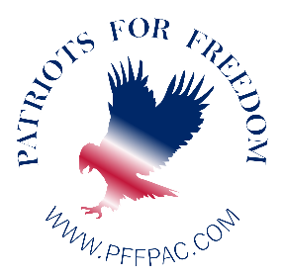

PATRIOTS FOR FREEDOM PAC ENDORSES KIZZIE SMALLS
FOR SOUTH CAROLINA HOUSE OF REPRESENTATIVES DISTRICT 77

Today May 20, 2022, Patriots for Freedom PAC announced its official endorsement of Kizzie Smalls for South Carolina House of Representatives.

Kizzie is carrying out her family legacy of public services with a long list of accomplishments. She served on the Georgetown City Planning Commission Board, and on the Mitney Project Committee, as well as serving as a Public-School Advocate for Children. She is the owner of Genesis Restoring the Foundations, and Co-Owner of Key Mills Express LLP an Independent Agent of Landstar. Kizzie Smalls has earned an Associate degree in Public Service from Horry Georgetown Technical College. In addition, she also earned a bachelor’s degree in Criminal Justice from Limestone University.

Kizzie’s extensive education and experience in public service makes her well qualified to represent the people of South Carolina as an elected official. Kizzie is acutely aware of the issues that are important to the people in her District and is ready to bring common sense solutions to the South Carolina legislature. Kizzie will fight for protect our Constitutional God given freedoms, the rule of law, fiscal responsibility, and the value and dignity of every human being. Kizzie stands firmly on a platform that is pro-life, America first, pro-Second Amendment, government transparency, and school choice. Her economic plan is simple, reducee regulatory burdens, keep taxes low and allow markets to work using the forces of supply and demand.

South Carolina residents deserve a leader with a proven record of public service, strong beliefs and convictions, and a commitment to be their voice in Columbia. Kizzie is that leader with a clear vision, and solutions to the problems that are affecting the citizens of District 77. She is an American success story and is ready to give back in serving the State people that she loves.

Patriots for Freedom PAC wholeheartedly endorses Kizzie Smalls for South Carolina House of Representatives District 77. To learn more about Kizzie Small’s campaign, please visit: votekizziesmalls.com

Patriots for Freedom was created in 2021. First as a civic organization meant to unite all committees throughout California under God first. Then as the year progressed and hundreds of concerned citizens across county lines began attending Patriots for Freedom meetings, founder Sonya Green made the bold decision to file PFF as a political action committee to elect patriots to all elected offices. To learn more about this organization, visit www.pffpac.com

